KD-5230
User manual

V2.6

Contents
Factory Defaults 9
Custom Defaults 10
Basic Settings 11
Interface 11
RS232 Baud Rate 12
RS232 Data Bits 13
RS232 Parity 14
RS232 Stop Bits 15
Keyboard Layout 16
Scan Mode 21
Sense Mode Sensitivity 22
Decode Redundancy 23
Decode Area 25
Decode Session Timeout 28
Time to Read Same Barcode 29
Time to Suspend State 31
Illumination Mode 32
Illumination Level 33
Aiming Pattern 34
Good Read Beep 35
Good Read Beep Frequency 36
Symbologies 37
Enable/Disable All Symbologies 37
Enable 1D/2D Symbologies 38
UPC-A 39
Enable/Disable UPC-A 39
Number System Transmission 40
Check Digit Transmission 41
Expand UPC-A to EAN13 42
UPC-A 2/5-Digit Add-ons 43
UPC-E 46
Enable/Disable UPC-E 46
Number System Transmission 47
Check Digit Transmission 48
Expand UPC-E to UPC-A 49
UPC-E 2/5-Digit Add-ons 50
EAN 13 53
Enable/Disable EAN 13 53
Check Digit Transmission 54
ISBN 55
EAN 13 2/5-Digit Add-ons 56
EAN 8 59
Enable/Disable EAN 8 59
Check Digit Transmission 60
Expand EAN 8 to EAN 13 61
EAN 8 2/5-Digit Add-ons 62
Code 128 / GS1-128 65
Enable/Disable Code 128 / GS1-128 65
GS1-128 AIM ID 66
Set Lengths for Code 128 67
Code 39 69
Enable/Disable Code 39 69
Code 39 Full ASCII 70
Check Character Calculation 71
Check Character Transmission 72
Start / Stop Characters 73
Set Lengths for Code 39 74
Code 93 76
Enable/Disable Code 93 76
Set Lengths for Code 39 77
Code 32 79
Enable/Disable Code 32 79
Pharmacode 80
Enable/Disable Pharmacode 80
Codabar 81
Enable/Disable Codabar 81
Check Character Verification 82
Check Character Transmission 83
Start / Stop Characters 84
Set Lengths for Codabar 85
MSI 87
Enable/Disable MSI 87
Check Character Calculation 88
Check Character Transmission 89
Check Character Algorithm 90
Set Lengths for MSI 91
Interleaved 2 of 5 93
Enable/Disable Interleaved 2 of 5 93
Check Character Calculation 94
Check Character Transmission 95
Set Lengths for Interleaved 2 of 5 96
GS1 DataBar 14 98
Enable/Disable GS1 DataBar 14 98
Application Identifier Transmission 99
GS1 DataBar 14 Stacked 100
Eeable/Disable GS1 DataBar 14 Stacked 100
Application Identifier Transmission 101
GS1 DataBar Expanded 102
Enable/Disable GS1 DataBar Expanded 102
Application Identifier Transmission 103
GS1 DataBar Expanded Stacked 104
Enable/Disable GS1 DataBar Expanded Stacked 104
Application Identifier Transmission 105
GS1 DataBar Limited 106
Enable/Dsiable GS1 DataBar Limited 106
Application Identifier Transmission 107
GS1 Composite Component A 108
Enable/Disable GS1 Composite Component A 108
GS1 Composite Component B 109
Enable/Disable GS1 Composite Component B 109
GS1 Composite Component C 110
Enable/Disable GS1 Composite Component C 110
PDF417 111
Enable/Disable PDF417 111
Micro PDF417 112
Enable/Disable Micro PDF417 112
Data Matrix 113
Enable/Disable Data Matrix 113
GS1 Data Matrix AIM ID 114
QR 115
Enable/Disable QR 115
GS1 QR AIM ID 116
Unicode Keyboard Output 117
Micro QR 127
Enable/Disable Micro QR 127
Aztec 128
Enable/Disable Aztec 128
MaxiCode 129
Enable/Disable MaxiCode 129
DotCode 130
Enable/Disable DotCode 130
GS1 DotCode AIM ID 131
Data Editing 132
Data Format 132
Prefix/Suffix 132
Truncate Data 135
Set Data for Codes 137
AIM ID 144
Keyboard Function Key Mapping 145
Keyboard Caps Lock State 147
Case Conversion 148
Control Characters Conversion 149
Appendix A - ASCII Codes 166
Appendix B - Direct Keys 198
Appendix C - Digit Number 211
Revision History 212

Factory Defaults


Start / End
Scanning the following barcode can restore the scanner to the factory defaults

Factory Defaults

Custom Defaults

Start / End
Scanning the Save as Custom Defaults barcode can set the current settings as custom defaults.
Scanning the Restore Custom Defaults barcode can reset all parameters to the custom defaults.


Save as Custom Defaults

Restore Custom Defaults

Basic Settings
Start / End

Interface
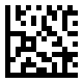 | 
USB Keyboard / DEFAULT | RS232 COM Port

USB Virtual COM Port

Start / End

RS232 Baud Rate
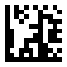 | 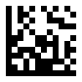
9600 / DEFAULT | 19200
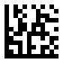 | 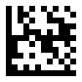
38400 | 57600
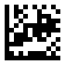 | 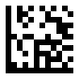
115200 | 230400

Start / End

RS232 Data Bits
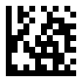
7 data bits
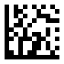
8 data bits / DEFAULT

Start / End

RS232 Parity
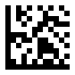 | 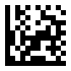
No Parity | Odd Parity
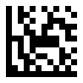
Even Parity

Start / End

RS232 Stop Bits
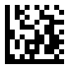
1 Stop bit / DEFAULT
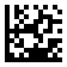
2 Stop bit

Start / End

Keyboard Layout
Keyboard layouts vary from country to country. The default setting is U.S. keyboard.
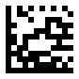 | 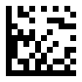
U.S. / DEFAULT | Belgium
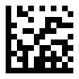 | 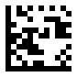
Britain | Brazil

Start / End
Keyboard Layout - Continued
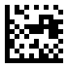 | 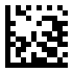
Czech Republic | Denmark
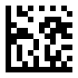 | 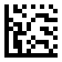
France | Germany

Start / End
Keyboard Layout - Continued
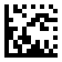 | 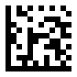
Hungary | Italy
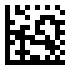 | 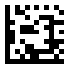
Japan | Norway

Start / End
Keyboard Layout - Continued
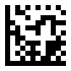 | 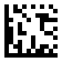
Poland | Portugal
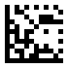 | 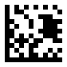
Romania | Spain

Start / End
Keyboard Layout - Continued
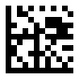 | 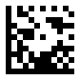
Sweden | Slovakia
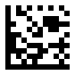
Turkish Q

Start / End

Scan Mode
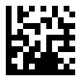 | 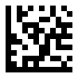
Trigger Mode / DEFAULT | Sense Mode
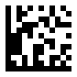
Continuous Mode

Start / End

Sense Mode Sensitivity
 | 
Low Sensitivity | Medium Sensitivity / DEFAULT
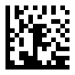
High Sensitivity

.

Decode Redundancy

The scanner offers three levels of decode redundancy. Select higher redundancy levels for decreasing levels of bar code quality.
As redundancy levels increase, the scanner's aggres-siveness decreases. Select the redundancy level appropriate for the bar code quality.

Redundancy Level 1
All code types just read one time.

Redundancy Level 2
All code types must be successfully read two times before being decoded.

Redundancy Level 3
All code types must be successfully read three times before being decoded.

Start / End
Decode Redundancy - Continued
 | 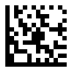
1 time / DEFAULT | 2 times
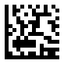
3 times

Decode Area
The scanner offers four settings of decode area.
Full size of image
To decode the barcode within full size of image

Decode Area
(100% of image)

75% of image
To decode the barcode within 75% of image

Ignore Area
(12.5% of image)
Decode Area
(75% of image)
Ignore Area
(12.5% of image)

Decode Area - Continued

50% of image
To decode the barcode within 50% of image

Ignore Area
(25% of image)
Decode Area
(50% of image)
Ignore Area
(25% of image)

25% of image
To decode the barcode within 25% of image

Ignore Area
(37.5% of image)
Decode Area
(25% of image)
Ignore Area
(37.5% of image)

Start / End
Decode Area - Continued
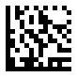 | 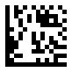
Full Size / DEFAULT | 75% of image
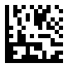 | 
50% of image | 25% of image

Decode Session Timeout
This parameter sets the maximum time decode session continues during a scan attempt. This feature is only applicable to the Trigger and Sense modes. It is programmable in 1ms increments from 1ms to 60,000 ms. When it is set to 0 , the timeout is infinite. The default setting is 5,000 ms.
Set the decode session timeout to 1,500 ms
1. Scan the Start barcode.
2. Scan the Decode Session Timeout barcode.
3. Scan the “1”, “5”, “0” and “0” barcodes from the Digit Number in Appendix C.
4. Scan the End barcode.
Start / End
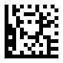
Decode Session Timeout

Time to Read Same Barcode
- Timeout between Decodes
Timeout between Decodes (Same Barcode) can avoid undesired rereading of same barcode in a given period of time. This feature is only applicable to the Sense and Continuous modes.
It is programmable in 1ms increments from 1ms to 5,000 ms. When it is set to 0, the timeout is disable. The default setting is 1500 ms.
- Ignore Same Code
Time to ignore the decode when read same barcode in a given period of time. This feature is only applicable to the Sense and Continuous modes.

Set the timeout between decodes to 500ms
1. Scan the Start barcode.
2. Scan the Timeout between Decodes barcode
3. Scan the “5”, “0” and “0” barcodes from the Digit Number in Appendix C.
4. Scan the End barcode.

Set the ignore same barcode to 250 ms
1. Scan the Start barcode.
2. Scan the Ignore Same Barcode
3. Scan the “2”, “5” and “0” barcodes from the Digit Number in Appendix C.
4. Scan the End barcode.

Start / End
Time to Read Same Barcode - Continued
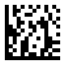
Timeout between Decodes / DEFAULT
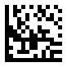
Ignore Same Barcode

Time to Suspend State
This parameter sets the time to enter to suspend state when the decoder is idle. This feature is only applicable to the Trigger and Continuous modes. It is programmable in 1 ms increments from 1ms to 36,00,000 ms. When it is set to 0, the timeout is disable. The default setting is 15,000 ms.
Set the time to suspend state to 2,500 ms
1. Scan the Start barcode.
2. Scan the Time to Suspend State barcode
3. Scan the “2”, “5”, “0” and “0” barcodes from the Digit Number in Appendix C.
4. Scan the End barcode.
Start / End

Time to Suspend State

Start / End

Illumination Mode
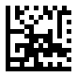 | 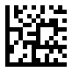
Disable | Enable by trigger / DEFAULT
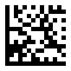 | 
Always On | Fade Up

Start / End

Illumination Level
 | 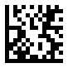
Minimum | Medium

Maximum / DEFAULT

Start / End

Aiming Pattern
 | 
Disable | Enable by trigger / DEFAULT

Always On

Start / End

Good Read Beep

Disable

Enable / DEFAULT

Start / End

Good Read Beep Frequency
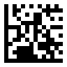 | 
Low | Medium / DEFAULT

High

Symbologies
Start / End

Enable/Disable All Symbologies
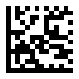
Enable All Symbologies

Disable All Symbologies

Start / End

Enable 1D/2D Symbologies

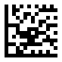
Enable 1D Symbologies

Enable 2D Symbologies

UPC-A

Start / End

Enable/Disable UPC-A

Enable UPC-A / DEFAULT

Disable UPC-A

Start / End

Number System Transmission
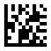
Enable Number System Transmission / DEFAULT

Disable Number System Transmission

Start / End

Check Digit Transmission
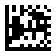
Send Check Digit / DEFAULT

Don't Send Check Digit

Start / End

Expand UPC-A to EAN13
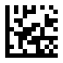
Don't Expand to EAN13 / DEFAULT
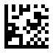
Expand to EAN13

Start / End

UPC-A 2/5-Digit Add-ons

Disable UPC-A Add-ons / DEFAULT

Enable UPC-A 2/5-Digit Add-ons

Start / End
UPC-A 2/5-Digit Add-ons - Continued
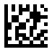
Enable UPC-A 2-Digit Add-ons

Enable UPC-A 5-Digit Add-ons

Start / End
UPC-A 2/5-Digit Add-ons - Continued
When UPC-A Add-ons Only is selected, the scanner will only read UPC-A barcodes that contain add-on codes.

Disable UPC-A Add-ons Only / DEFAULT

Enable UPC-A Add-ons Only

UPC-E

Start / End

Enable/Disable UPC-E

Enable UPC-E / DEFAULT

Disable UPC-E

Start / End

Number System Transmission

Enable Number System Transmission / DEFAULT

Disable Number System Transmission

Start / End

Check Digit Transmission

Send Check Digit / DEFAULT
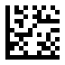
Don't Send Check Digit

Start / End

Expand UPC-E to UPC-A
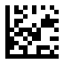
Don't Expand to UPC-A / DEFAULT
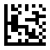
Expand to UPC-A

Start / End

UPC-E 2/5-Digit Add-ons
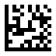
Disable UPC-E Add-ons / DEFAULT

Enable UPC-E 2/5-Digit Add-ons

Start / End
UPC-E 2/5-Digit Add-ons - Continued
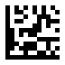
Enable UPC-E 2-Digit Add-ons

Enable UPC-E 5-Digit Add-ons

Start / End
UPC-E 2/5-Digit Add-ons - Continued
When UPC-E Add-ons Only is selected, the scanner will only read UPC-A barcodes that contain add-on codes.
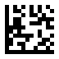
Disable UPC-E Add-ons Only / DEFAULT

Enable UPC-E Add-ons Only

EAN 13

Start / End

Enable/Disable EAN 13

Enable EAN 13 / DEFAULT

Disable EAN 13

Start / End

Check Digit Transmission

Send Check Digit / DEFAULT
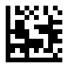
Don't Send Check Digit

Start / End

ISBN

Disable ISBN / DEFAULT

Enable ISBN

Start / End

EAN 13 2/5-Digit Add-ons

Disable EAN 13 Add-ons / DEFAULT

Enable EAN 13 2/5-Digit Add-ons

Start / End
EAN 13 2/5-Digit Add-ons - Continued
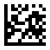
Enable EAN 13 2-Digit Add-ons
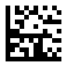
Enable EAN 13 5-Digit Add-ons

Start / End
EAN 13 2/5-Digit Add-ons - Continued
When EAN 13 Add-ons Only is selected, the scanner will only read UPC-A barcodes that contain add-on codes.
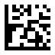
Disable EAN 13 Add-ons Only / DEFAULT
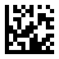
Enable EAN 13 Add-ons Only

EAN 8

Start / End

Enable/Disable EAN 8

Enable EAN 8 / DEFAULT

Disable EAN 8

Start / End

Check Digit Transmission
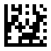
Send Check Digit / DEFAULT
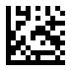
Don't Send Check Digit

Start / End

Expand EAN 8 to EAN 13

Don't Expand to EAN 13 / DEFAULT
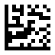
Expand to EAN 13

Start / End

EAN 8 2/5-Digit Add-ons
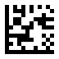
Disable EAN 8 Add-ons / DEFAULT
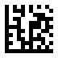
Enable EAN 8 2/5-Digit Add-ons

Start / End
EAN 8 2/5-Digit Add-ons - Continued
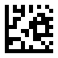
Enable EAN 8 2-Digit Add-ons
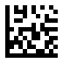
Enable EAN 8 5-Digit Add-ons

Start / End
EAN 8 2/5-Digit Add-ons - Continued
When EAN 8 Add-ons Only is selected, the scanner will only read UPC-A barcodes that contain add-on codes.
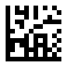
Disable EAN 8 Add-ons Only / DEFAULT
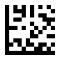
Enable EAN 8 Add-ons Only

Code 128 / GS1-128

Start / End

Enable/Disable Code 128 / GS1-128

Enable Code 128 / GS1-128 / DEFAULT

Disable Code 128 / GS1-128

Start / End

GS1-128 AIM ID

Transmit GS1-128 AIM ID

Do Not Transmit GS1-128 AIM ID / DEFAULT

Set Lengths for Code 128

- One Discrete Length
Select this option to decode the symbol containing a selected length.
Select the length using the numeric bar codes in ASCII Code. For example, to decode only Code 128 symbols with 14 characters, scan Code 128 One Discrete Length, then scan 1 followed by 4.

- Two Discrete Lengths
Select this option to decode the symbol containing either of two selected lengths. Select lengths using the numeric bar codes in ASCII Code. For example, to decode only Code 128 symbols containing either 2 or 14 characters, select Code 128 Two Discrete Lengths, then scan 0, 2, 1, and then 4.

- Length Within Range
Select this option to decode the symbol with a specific length range.
Select lengths using numeric bar codes in ASCII Code. For example, to decode
Code 128 symbols containing between 4 and 12 characters, first scan Code 128 Length Within Range. Then scan 0, 4, 1, and 2.

- Any Length
Select this option to decode the symbol containing any number of characters within the digital scanner’s capability.

Start / End
Set Lengths for Code 128 - Continued
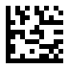 | 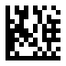
One Discrete Length | Two Discrete Lengths
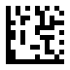 | 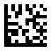
Length Within Range | Any Length / DEFAULT

Code 39

Start / End

Enable/Disable Code 39

Enable Code 39 / DEFAULT

Disable Code 39

Start / End

Code 39 Full ASCII
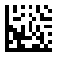
Disable Code 39 Full ASCII / DEFAULT

Enable Code 39 Full ASCII

Start / End

Check Character Calculation
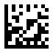
Disable Check Char Calculation / DEFAULT
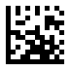
Enable Check Char Calculation

Start / End

Check Character Transmission
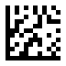
Disable Check Char Transmission / DEFAULT

Enable Check Char Transmission

Start / End

Start / Stop Characters
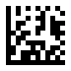
Don't Transmit Start / Stop Characters / DEFAULT
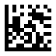
Transmit Start / Stop Characters

Set Lengths for Code 39

- One Discrete Length
Select this option to decode the symbol containing a selected length.
Select the length using the numeric bar codes in ASCII Code. For example, to decode only Code 39 symbols with 14 characters, scan Code 39 One Discrete Length, then scan 1 followed by 4.

- Two Discrete Lengths
Select this option to decode the symbol containing either of two selected lengths. Select lengths using the numeric bar codes in ASCII Code. For example, to decode only Code 39 symbols containing either 2 or 14 characters, select Code 39 Two Discrete Lengths, then scan 0, 2, 1, and then 4.

- Length Within Range
Select this option to decode the symbol with a specific length range.
Select lengths using numeric bar codes in ASCII Code. For example, to decode
Code 39 symbols containing between 4 and 12 characters, first scan Code 39 Length Within Range. Then scan 0, 4, 1, and 2.

- Any Length
Select this option to decode the symbol containing any number of characters within the digital scanner’s capability.

Start / End
Set Lengths for Code 39 - Continued
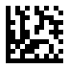 | 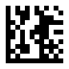
One Discrete Length | Two Discrete Lengths
 | 
Length Within Range | Any Length / DEFAULT

Code 93

Start / End

Enable/Disable Code 93

Enable Code 93 / DEFAULT

Disable Code 93

Set Lengths for Code 93

- One Discrete Length
Select this option to decode the symbol containing a selected length.
Select the length using the numeric bar codes in ASCII Code. For example, to decode only Code 93 symbols with 14 characters, scan Code 93 One Discrete Length, then scan 1 followed by 4.

- Two Discrete Lengths
Select this option to decode the symbol containing either of two selected lengths. Select lengths using the numeric bar codes in ASCII Code. For example, to decode only Code 93 symbols containing either 2 or 14 characters, select Code 93 Two Discrete Lengths, then scan 0, 2, 1, and then 4.

- Length Within Range
Select this option to decode the symbol with a specific length range.
Select lengths using numeric bar codes in ASCII Code. For example, to decode
Code 93 symbols containing between 4 and 12 characters, first scan Code 93 Length Within Range. Then scan 0, 4, 1, and 2.

- Any Length
Select this option to decode the symbol containing any number of characters within the digital scanner’s capability.

Start / End
Set Lengths for Code 93 - Continued
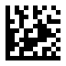 | 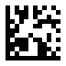
One Discrete Length | Two Discrete Lengths
 | 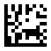
Length Within Range | Any Length / DEFAULT

Code 32

Start / End

Enable/Disable Code 32

Enable Code 32

Disable Code 32 / DEFAULT

Pharmacode

Start / End

Enable/Disable Pharmacode

Enable Pharmacode

Disable Pharmacode / DEFAULT

Codabar

Start / End

Enable/Disable Codabar
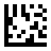
Enable Codabar

Disable Codabar / DEFAULT

Start / End

Check Character Verification
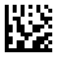
Disable Check Char Verification / DEFAULT
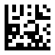
Enable Check Char Verification

Start / End

Check Character Transmission
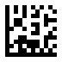
Disable Check Char Transmission / DEFAULT
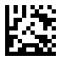
Enable Check Char Transmission

Start / End

Start / Stop Characters
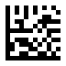
Transmit Start / Stop Characters

Don't Transmit Start / Stop Characters / DEFAULT

Set Lengths for Codabar

- One Discrete Length
Select this option to decode the symbol containing a selected length.
Select the length using the numeric bar codes in ASCII Code. For example, to decode only Codabar symbols with 14 characters, scan Codabar One Discrete Length, then scan 1 followed by 4.

- Two Discrete Lengths
Select this option to decode the symbol containing either of two selected lengths. Select lengths using the numeric bar codes in ASCII Code. For example, to decode only Codabar symbols containing either 2 or 14 characters, select Codabar Two Discrete Lengths, then scan 0, 2, 1, and then 4.

- Length Within Range
Select this option to decode the symbol with a specific length range.
Select lengths using numeric bar codes in ASCII Code. For example, to decode
Codabar symbols containing between 4 and 12 characters, first scan Codabar Length Within Range. Then scan 0, 4, 1, and 2.

- Any Length
Select this option to decode the symbol containing any number of characters within the digital scanner’s capability.

Start / End
Set Lengths for Codabar - Continued
 | 
One Discrete Length | Two Discrete Lengths
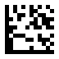 | 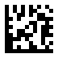
Length Within Range | Any Length / DEFAULT

MSI

Start / End

Enable/Disable MSI

Enable MSI

Disable MSI / DEFAULT

Start / End

Check Character Calculation

Enable Check Char Calculation / DEFAULT
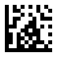
Disable Check Char Calculation

Start / End

Check Character Transmission
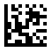
Enable Check Char Transmission / DEFAULT
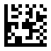
Disable Check Char Transmission

Start / End

Check Character Algorithm
 | 
MOD 10 / DEFAULT | MOD 10 / MOD 10
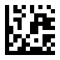
MOD 10 / MOD 11

Set Lengths for MSI

- One Discrete Length
Select this option to decode the symbol containing a selected length.
Select the length using the numeric bar codes in ASCII Code. For example, to decode only MSI symbols with 14 characters, scan MSI One Discrete Length, then scan 1 followed by 4.

- Two Discrete Lengths
Select this option to decode the symbol containing either of two selected lengths. Select lengths using the numeric bar codes in ASCII Code. For example, to decode only MSI symbols containing either 2 or 14 characters, select MSI Two Discrete Lengths, then scan 0, 2, 1, and then 4.

- Length Within Range
Select this option to decode the symbol with a specific length range.
Select lengths using numeric bar codes in ASCII Code. For example, to decode
MSI symbols containing between 4 and 12 characters, first scan MSI Length Within Range. Then scan 0, 4, 1, and 2.

- Any Length
Select this option to decode the symbol containing any number of characters within the digital scanner’s capability.

Start / End
Set Lengths for MSI - Continued
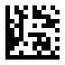 | 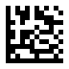
One Discrete Length | Two Discrete Lengths
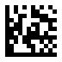 | 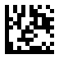
Length Within Range | Any Length / DEFAULT

Interleaved 2 of 5

Start / End

Enable/Disable Interleaved 2 of 5
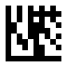
Enable Interleaved 2 of 5 / DEFAULT

Disable Interleaved 2 of 5

Start / End

Check Character Calculation
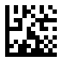
Disable Check Char Calculation / DEFAULT
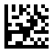
Enable Check Char Calculation

Start / End

Check Character Transmission
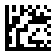
Disable Check Char Transmission / DEFAULT

Enable Check Char Transmission

Set Lengths for Interleaved 2 of 5

- One Discrete Length
Select this option to decode the symbol containing a selected length.
Select the length using the numeric bar codes in ASCII Code. For example, to decode only Interleaved 2 of 5 symbols with 14 characters, scan Interleaved 2 of 5 One Discrete Length, then scan 1 followed by 4.

- Two Discrete Lengths
Select this option to decode the symbol containing either of two selected lengths. Select lengths using the numeric bar codes in ASCII Code. For example, to decode only Interleaved 2 of 5 symbols containing either 2 or 14 characters, select Interleaved 2 of 5 Two Discrete Lengths, then scan 0, 2, 1, and then 4.

- Length Within Range
Select this option to decode the symbol with a specific length range.
Select lengths using numeric bar codes in ASCII Code. For example, to decode
Interleaved 2 of 5 symbols containing between 4 and 12 characters, first scan Interleaved 2 of 5 Length Within Range. Then scan 0, 4, 1, and 2.

- Any Length
Select this option to decode the symbol containing any number of characters within the digital scanner’s capability.

Start / End
Set Lengths for Interleaved 2 of 5 - Continued
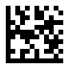 | 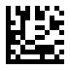
One Discrete Length | Two Discrete Lengths
 | 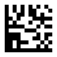
Length Within Range | Any Length / DEFAULT

GS1 DataBar 14

Start / End

Enable/Disable GS1 DataBar 14

Enable GS1 DataBar 14 / DEFAULT

Disable DataBar 14

Start / End

Application Identifier Transmission

Enable Application Identifier “01” Transmission/ DEFAULT

Disable Application Identifier “01” Transmission

GS1 DataBar 14 Stacked

Start / End

Enable/Disable GS1 DataBar 14 Stacked

Enable GS1 DataBar 14 Stacked / DEFAULT

Disable GS1 DataBar 14 Stacked

Start / End

Application Identifier Transmission
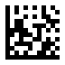
Enable Application Identifier “01” Transmission/ DEFAULT

Disable Application Identifier “01” Transmission

GS1 DataBar Expanded

Start / End

Enable/Disable GS1 DataBar Expanded
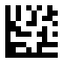
Enab Enable GS1 DataBar Expanded / DEFAULT

Disable GS1 DataBar Expanded

Start / End

Application Identifier Transmission

Enable Application Identifier “01” Transmission/ DEFAULT
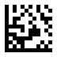
Disable Application Identifier “01” Transmission

GS1 DataBar Expanded Stacked

Start / End

Enable/Disable GS1 DataBar Expanded Stacked

Enable GS1 DataBar Expanded Stacked / DEFAULT

Disable GS1 DataBar Expanded Stacked

Start / End

Application Identifier Transmission

Enable Application Identifier “01” Transmission/ DEFAULT
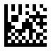
Disable Application Identifier “01” Transmission

GS1 DataBar Limited

Start / End

Enable/Dsiable GS1 DataBar Limited

Enable GS1 DataBar Limited / DEFAULT

Disable GS1 DataBar Limited

Start / End

Application Identifier Transmission
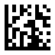
Enable Application Identifier “01” Transmission/ DEFAULT

Disable Application Identifier “01” Transmission

GS1 Composite Component A
Start / End

Enable/Disable GS1 Composite Component A

Enable CC-A

Disable CC-A / DEFAULT

GS1 Composite Component B
Start / End

Enable/Disable GS1 Composite Component B

Enable CC-B

Disable CC-B / DEFAULT

GS1 Composite Component C
Start / End

Enable/Disable GS1 Composite Component C

Enable CC-C

Disable CC-C / DEFAULT

PDF417

Start / End

Enable/Disable PDF417

Enable PDF417 / DEFAULT

Disable PDF417

Micro PDF417

Start / End

Enable/Disable Micro PDF417

Enable Micro PDF417

Disable Micro PDF417 / DEFAULT

Data Matrix

Start / End

Enable/Disable Data Matrix

Enable Data Matrix / DEFAULT
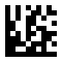
Disable Data Matrix

Start / End

GS1 Data Matrix AIM ID

Transmit GS1 Data Matrix AIM ID

Do Not Transmit GS1 Data Matrix AIM ID / DEFAULT

QR

Start / End

Enable/Disable QR

Enable QR / DEFAULT
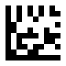
Disable QR

Start / End

GS1 QR AIM ID
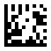
Transmit GS1 QR AIM ID
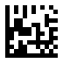
Do Not Transmit GS1 QR AIM ID / DEFAULT

Start / End

Unicode Keyboard Output
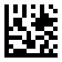
Microsoft O Unicode - UTF8 Keyboard Output / DEFAULT
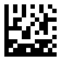
Microsoft Office Word - UTF8 / Codepage Keyboard Output

Start / End
Unicode Keyboard Output - Continued
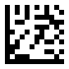
GB2312 - QR Keyboard Output
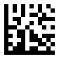
GB2312 - Microsoft Office Word

Start / End
Unicode Keyboard Output - Continued
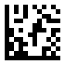
Big 5 - QR Keyboard Output
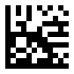
Big 5 - Microsoft Office Word

Start / End
Unicode Keyboard Output - Continued
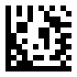
Shift JIS - QR Keyboard Output
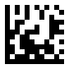
Shift JIS - Microsoft Office Word

Start / End
Unicode Keyboard Output - Continued
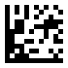
Thai - UTF8 QR Keyboard Output
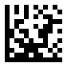
Russian - UTF8 QR Keyboard Output
Start / End
Unicode Keyboard Output - Continued
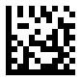
Turkish - UTF8 QR Keyboard Output
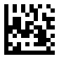
German - UTF8 QR Keyboard Output

Start / End
Unicode Keyboard Output - Continued
Dutch - UTF8 QR Keyboard Output
Italian - UTF8 QR Keyboard Output

Start / End
Unicode Keyboard Output - Continued
French - UTF8 QR Keyboard Output
Spanish - UTF8 QR Keyboard Output

Start / End
Unicode Keyboard Output - Continued
Portuguese - UTF8 QR Keyboard Output
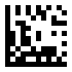
Brazil - UTF8 QR Keyboard Output

Start / End
Unicode Keyboard Output - Continued
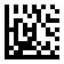
Arabic - UTF8 QR Keyboard Output
Malaysia - UTF8 QR Keyboard Output

Micro QR

Start / End

Enable/Disable Micro QR

Enable Micro QR
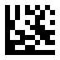
Disable Micro QR / DEFAULT

Aztec

Start / End

Enable/Disable Aztec

Enable Aztec

Disable Aztec / DEFAULT

MaxiCode

Start / End

Enable/Disable MaxiCode

Enable MaxiCode

Disable MaxiCode / DEFAULT

DotCode

Start / End

Enable/Disable DotCode

Enable DotCode

Disable DotCode / DEFAULT

Start / End

GS1 DotCode AIM ID

Transmit GS1 DotCode AIM ID
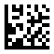
Do Not Transmit GS1 DotCode AIM ID / DEFAULT

Data Editing

Data Format
The scan data is transmitted as below format.
Prefix | AIM ID | Scan Data | Suffix

Prefix/Suffix
One to six prefixes and/or suffixes can be appended to scan data for use in data editing.

Example:

Set two Prefixes/Suffixes for all codes
<Enter programming Mode>
<Set Prefix> or <Set Suffix>
<Set All Codes>
<Set first code of ASCII Codes or Direct Keys >
<Set second code of ASCII Codes or Direct Keys >
<Exit programming Mode>

Disable Prefixes/Suffixes for all codes
<Enter programming Mode>
<Disable Prefix> or <Disable Suffix>
<Set All Codes>
<Exit programming Mode>

Start / End
Set Prefix - Continued

Set Prefix
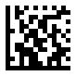
Disable Prefix / DEFAULT

Start / End
Set Suffix - Continued

Set Suffix
(Default CR for all codes)
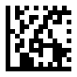
Disable Suffix

Truncate Data
This parameter sets the number of leading or ending data to be truncated. It is programmable in 1 increment from 1 to 99 characters. The default setting is 0.
Truncate 5 characters of leading for all codes
1. Scan the Start barcode.
2. Scan the Truncate Leading barcode.
2. Scan the All Codes barcode.
3. Scan the “5” barcode from the Digit Number in Appendix C.
4. Scan the End barcode.
Truncate 8 characters of Leading for Data Matrix
1. Scan the Start barcode.
2. Scan the Truncate Leading barcode.
2. Scan the Data Matrix barcode.
3. Scan the “8” barcode from the Digit Number in Appendix C.
4. Scan the End barcode.
Truncate 10 characters of Ending for QR
1. Scan the Start barcode.
2. Scan the Truncate Leading barcode.
2. Scan the QR barcode.
3. Scan the “1” and “0” barcodes from the Digit Number in Appendix C.
4. Scan the End barcode.
Start / End
Truncate Data - Continued

Truncate Leading

Truncate Ending

Start / End

Set Data for Codes
 | 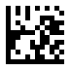
Set All Codes | UPC-A
 | 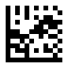
UPC-E | EAN 13

Start / End
Set Data for Codes - Continued
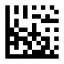 | 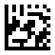
EAN 8 | Code 128
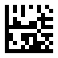 | 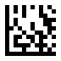
Code 39 | Code 93

Start / End
Set Data for Codes - Continued
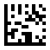 | 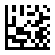
Code 32 | Pharmacode
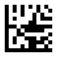 | 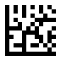
Codabar | MSI

Start / End
Set Data for Codes - Continued
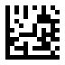 | 
Interleaved 2 of 5 | GS1 DataBar 14
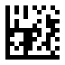 | 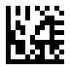
GS1 DataBar 14 Stacked | GS1 DataBar Expanded

Start / End
Set Data for Codes - Continued
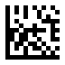 | 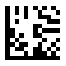
GS1 DataBar Expanded Stacked | GS1 DataBar Limited
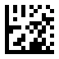 | 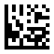
CC-A | CC-B

Start / End
Set Data for Codes - Continued
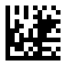 | 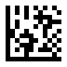
CC-C | PDF417
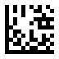 | 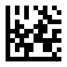
Micro PDF417 | Data Matrix

Start / End
Set Data for Codes - Continued
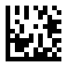 | 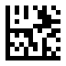
QR | Micro QR
 | 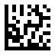
Aztec | MaxiCode

Start / End

AIM ID

Disable Transmission of AIM ID / DEFAULT

Enable Transmission of AIM ID

Start / End

Keyboard Function Key Mapping
Enable this to send the keys in bold (see ASCII Codes) in place of the standard key mapping. Table entries that do not have a bold entry remain the same whether or not this parameter is enabled
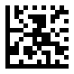
Disable Function Key Mapping

Enable Function Key Mapping / DEFAULT
Start / End
Keyboard Function Key Mapping - Continued

Ctrl + ASCII Mode / DEFAULT
Control Characters (0x00 - 0x1F) are sent as ASCII sequences.

Alt + Numeric Keypad Mode
Control Characters (0x00 - 0x1F) are sent as Unicode code sequences.

Start / End

Keyboard Caps Lock State
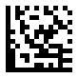
Caps Lock Off / DEFAULT

Caps Lock On

Start / End

Case Conversion
 | 
Disable / DEFAULT | Convert to Upper Case

Convert to Lower Case

Note: Case Conversion does not affect AIM ID , Prefix , Suffix.

Control Characters Conversion
Convert Control Characters (0x00 - 0x1F) to other keystroke.
Set ASCII value 29 [GS] to #
1. Scan the Start barcode.
2. Scan the GS Conversion barcode.
3. Scan the # barcode from the ASCII Code in Appendix A.
4. Scan the End barcode.

Disable ASCII value 29 [GS] conversion
1. Scan the Start barcode.
2. Scan the Disable GS Conversion barcode.
4. Scan the End barcode.

Start / End
Control Characters Conversion - Continued
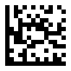 | 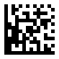
NUL Conversion | Disable NUL Conversion
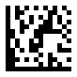 | 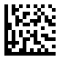
SOH Conversion | Disable SOH Conversion

Start / End
Control Characters Conversion - Continued
 | 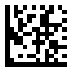
STX Conversion | Disable STX Conversion
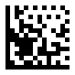 | 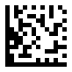
ETX Conversion | Disable ETX Conversion

Start / End
Control Characters Conversion - Continued
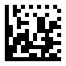 | 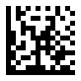
EOT Conversion | Disable EOT Conversion
 | 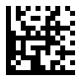
ENQ Conversion | Disable ENQ Conversion

Start / End
Control Characters Conversion - Continued
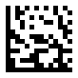 | 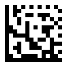
ACK Conversion | Disable ACK Conversion
 | 
BEL Conversion | Disable BEL Conversion

Start / End
Control Characters Conversion - Continued
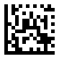 | 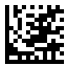
BS Conversion | Disable BS Conversion
 | 
HT Conversion | Disable HT Conversion

Start / End
Control Characters Conversion - Continued
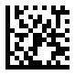 | 
LF Conversion | Disable LF Conversion
 | 
VT Conversion | Disable VT Conversion

Start / End
Control Characters Conversion - Continued
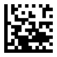 | 
FF Conversion | Disable FF Conversion
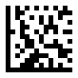 | 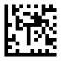
CR Conversion | Disable CR Conversion

Start / End
Control Characters Conversion - Continued
 | 
SO Conversion | Disable SO Conversion
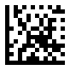 | 
SI Conversion | Disable SI Conversion

Start / End
Control Characters Conversion - Continued
 | 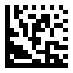
DLE Conversion | Disable DLE Conversion
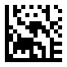 | 
DC1 Conversion | Disable DC1 Conversion

Start / End
Control Characters Conversion - Continued
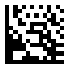 | 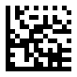
DC2 Conversion | Disable DC2 Conversion
 | 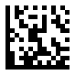
DC3 Conversion | Disable DC3 Conversion

Start / End
Control Characters Conversion - Continued
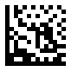 | 
DC4 Conversion | Disable DC4 Conversion
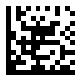 | 
NAK Conversion | Disable NAK Conversion

Start / End
Control Characters Conversion - Continued
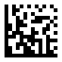 | 
SYN Conversion | Disable SYN Conversion
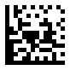 | 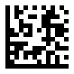
ETB Conversion | Disable ETB Conversion

Start / End
Control Characters Conversion - Continued
 | 
CAN Conversion | Disable CAN Conversion
 | 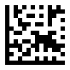
EM Conversion | Disable EM Conversion

Start / End
Control Characters Conversion - Continued
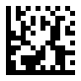 | 
SUB Conversion | Disable SUB Conversion
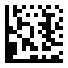 | 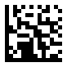
ESC Conversion | Disable ESC Conversion

Start / End
Control Characters Conversion - Continued
 | 
FS Conversion | Disable FS Conversion
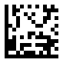 | 
GS Conversion | Disable GS Conversion

Start / End
Control Characters Conversion - Continued
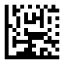 | 
RS Conversion | Disable RS Conversion
 | 
US Conversion | Disable US Conversion

Appendix A - ASCII Codes
ASCII  (hex) | Serial | Keystroke
01 | SOH | ENTER  /  CTRL+A | 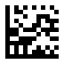
02 | STX | F11  /  CTRL+B | 
03 | ETX | F12  /  CTRL+C | 
04 | EOT | NULL  /  CTRL+D | 
The keystroke in bold is sent only if Function Key Mapping is enabled. Otherwise, the unbolded keystroke is sent.

ASCII Codes - Continued
ASCII  (hex) | Serial | Keystroke
05 | ENQ | NULL  /  CTRL+E | 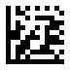
06 | ACK | NULL  /  CTRL+F | 
07 | BEL | NULL  /  CTRL+G | 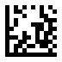
08 | BACKSPACE | BACKSPACE | 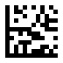
The keystroke in bold is sent only if Function Key Mapping is enabled. Otherwise, the unbolded keystroke is sent.

ASCII Codes - Continued
ASCII  (hex) | Serial | Keystroke
09 | TAB | TAB | 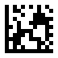
0A | LF | RIGHT  /  CTRL+J | 
0B | VT | NULL  /  CTRL+K | 
0C | FF | NULL  /  CTRL+L | 
The keystroke in bold is sent only if Function Key Mapping is enabled. Otherwise, the unbolded keystroke is sent.

ASCII Codes - Continued
ASCII  (hex) | Serial | Keystroke
0D | CR | ENTER | 
0E | SO | INSERT  /  CTRL+N | 
0F | SI | Page Up  /  CTRL+O | 
10 | DLE | Page Down  /  CTRL+P
The keystroke in bold is sent only if Function Key Mapping is enabled. Otherwise, the unbolded keystroke is sent.

ASCII Codes - Continued
ASCII  (hex) | Serial | Keystroke
11 | DC1 | HOME  /  CTRL+Q | 
12 | DC2 | LEFT  /  CTRL+R | 
13 | DC3 | DWON  /  CTRL+S | 
14 | DC4 | Up  /  CTRL+T | 
The keystroke in bold is sent only if Function Key Mapping is enabled. Otherwise, the unbolded keystroke is sent.

ASCII Codes - Continued
ASCII  (hex) | Serial | Keystroke
15 | NAK | F6  /  CTRL+U
16 | SYN | F1  /  CTRL+V
17 | ETB | F2  /  CTRL+W
18 | CAN | F3  /  CTRL+X
The keystroke in bold is sent only if Function Key Mapping is enabled. Otherwise, the unbolded keystroke is sent.

ASCII Codes - Continued
ASCII  (hex) | Serial | Keystroke
19 | EM | F4  /  CTRL+Y | 
1A | SUB | F5  /  CTRL+Z | 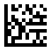
1B | ESC | ESC  /  CTRL+[ | 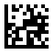
1C | FS | F7  /  CTRL+\ | 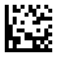
The keystroke in bold is sent only if Function Key Mapping is enabled. Otherwise, the unbolded keystroke is sent.
ASCII Codes - Continued
ASCII  (hex) | Serial | Keystroke
1D | GS | F8  /  CTRL+] |  | 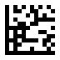
1E | RS | F9  /  CTRL+^ |  | 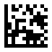
1F | US | F10  /  CTRL+_ |  | 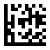
20 | SPACE | SPACE |  | 
The keystroke in bold is sent only if Function Key Mapping is enabled. Otherwise, the unbolded keystroke is sent.

ASCII Codes - Continued
ASCII  (hex) | Serial | Keystroke
21 | ! | ! | 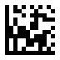
22 | " | " | 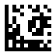
23 | # | # | 
24 | $ | $ | 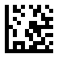
ASCII Codes - Continued
ASCII  (hex) | Serial | Keystroke
25 | % | % |  | 
26 | & | & |  | 
27 | ' | ' |  | 
28 | ( | ( |  | 
ASCII Codes - Continued
ASCII  (hex) | Serial | Keystroke
29 | ) | ) | 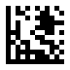
2A | * | * | 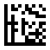
2B | + | + | 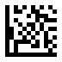
2C | , | , | 
ASCII Codes - Continued
ASCII  (hex) | Serial | Keystroke
2D | - | - |  | 
2E | . | . |  | 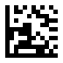
2F | / | / |  | 
30 | 0 | 0 |  | 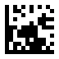
ASCII Codes - Continued
ASCII  (hex) | Serial | Keystroke
31 | 1 | 1 | 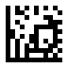
32 | 2 | 2 | 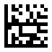
33 | 3 | 3 | 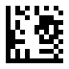
34 | 4 | 4 | 
ASCII Codes - Continued
ASCII  (hex) | Serial | Keystroke
35 | 5 | 5 |  | 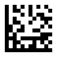
36 | 6 | 6 |  | 
37 | 7 | 7 |  | 
38 | 8 | 8 |  | 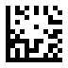
ASCII Codes - Continued
ASCII  (hex) | Serial | Keystroke
39 | 9 | 9 |  | 
3A | : | : |  | 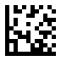
3B | ; | ; |  | 
3C | < | < |  | 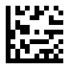
ASCII Codes - Continued
ASCII  (hex) | Serial | Keystroke
3D | = | = | 
3E | > | > | 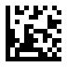
3F | ? | ? | 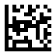
40 | @ | @ | 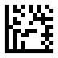
ASCII Codes - Continued
ASCII  (hex) | Serial | Keystroke
41 | A | A | 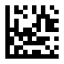
42 | B | B | 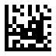
43 | C | C | 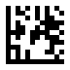
44 | D | D | 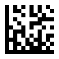
ASCII Codes - Continued
ASCII  (hex) | Serial | Keystroke
45 | E | E | 
46 | F | F | 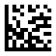
47 | G | G | 
48 | H | H | 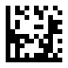
ASCII Codes - Continued
ASCII  (hex) | Serial | Keystroke
49 | I | I | 
4A | J | J | 
4B | K | K | 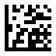
4C | L | L | 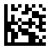
ASCII Codes - Continued
ASCII  (hex) | Serial | Keystroke
4D | M | M | 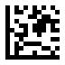
4E | N | N | 
4F | O | O | 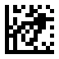
50 | P | P | 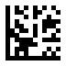
ASCII Codes - Continued
ASCII  (hex) | Serial | Keystroke
51 | Q | Q | 
52 | R | R | 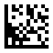
53 | S | S | 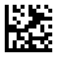
54 | T | T | 
ASCII Codes - Continued
ASCII  (hex) | Serial | Keystroke
55 | U | U | 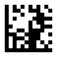
56 | V | V | 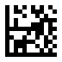
57 | W | W | 
58 | X | X | 
ASCII Codes - Continued
ASCII  (hex) | Serial | Keystroke
59 | Y | Y | 
5A | Z | Z | 
5B | [ | [ | 
5C | \ | \ | 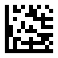
ASCII Codes - Continued
ASCII  (hex) | Serial | Keystroke
5D | ] | ] | 
5E | ^ | ^ | 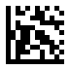
5F | _ | _ | 
60 | ' | ' | 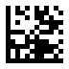
ASCII Codes - Continued
ASCII  (hex) | Serial | Keystroke
61 | a | a | 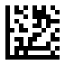
62 | b | b | 
63 | c | c | 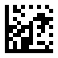
64 | d | d | 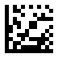
ASCII Codes - Continued
ASCII  (hex) | Serial | Keystroke
65 | e | e | 
66 | f | f | 
67 | g | g | 
68 | h | h | 
ASCII Codes - Continued
ASCII  (hex) | Serial | Keystroke
69 | i | i | 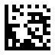
6A | j | j | 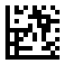
6B | k | k | 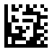
6C | l | l | 
ASCII Codes - Continued
ASCII  (hex) | Serial | Keystroke
6D | m | m | 
6E | n | n | 
6F | o | o | 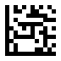
70 | p | p | 
ASCII Codes - Continued
ASCII  (hex) | Serial | Keystroke
71 | q | q | 
72 | r | r | 
73 | s | s | 
74 | t | t | 
ASCII Codes - Continued
ASCII  (hex) | Serial | Keystroke
75 | u | u | 
76 | v | v | 
77 | w | w | 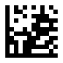
78 | x | x | 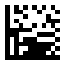
ASCII Codes - Continued
ASCII  (hex) | Serial | Keystroke
79 | y | y | 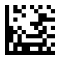
7A | z | z | 
7B | { | { | 
7C | | | | | 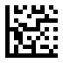
ASCII Codes - Continued
ASCII  (hex) | Serial | Keystroke
7D | } | } | 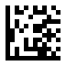
7E | ~ | ~ | 

Appendix B - Direct Keys

F1

F2
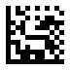
F3

F4

Direct Keys - Continued

F5

F6

F7
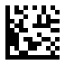
F8

Direct Keys - Continued

F9

F10
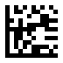
F11
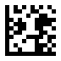
F12

Direct Keys - Continued

INSERT

DELETE
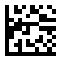
HOME

END

Direct Keys - Continued

Arrow Up
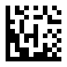
Arrow Down
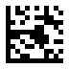
Arrow Left

Arrow Right

Direct Keys - Continued

CTRL
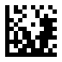
ALT
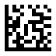
SHIFT

Page Up

Direct Keys - Continued

Page Down
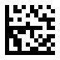
ALT+a

ALT+b
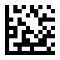
ALT+c

Direct Keys - Continued
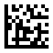
ALT+d

ALT+e

ALT+f
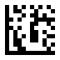
ALT+g

Direct Keys - Continued
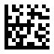
ALT+h
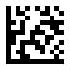
ALT+i

ALT+j
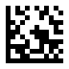
Ctrl+k

Direct Keys - Continued

ALT+l
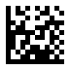
ALT+m

ALT+n

ALT+o

Direct Keys - Continued
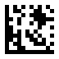
ALT+p

ALT+q

ALT+r

ALT+s

Direct Keys - Continued

ALT+t

ALT+u
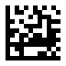
ALT+v
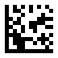
ALT+w

Direct Keys - Continued
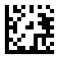
ALT+x
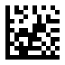
ALT+y
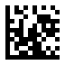
ALT+z

Appendix C - Digit Number
0 | 1
2 | 3
4 | 5
6 | 7
8 | 9

